November 2024 - Meal Calendar |  |  |  |  |  |  | November 2024 - Activity Calendar
MONDAY | TUESDAY | WEDNESDAY | THURSDAY | FRIDAY |  | MONDAY |  | TUESDAY | WEDNESDAY | THURSDAY | FRIDAY
 |  |  |  | 1  11:30a-12:30p Lunch  Pepper Steak, Brown Rice, Stir Fry Vegetable, Sugar Snap Peas, and Kiwi |  |  |  |  |  |  | 1  10:45a Fit for the Aging  1p Pantry Bingo
4  11:30a-12:30p Lunch  Chicken Tenders,  Cheesy Mashed Potatoes, Broccoli and Cauliflower, Orange  4:30-5:30pm Dinner  Chicken Enchiladas, Corn and Black Bean Fiesta, Applesauce | 5  11:30a-12:30p Lunch  Spaghetti and Meatballs, Broccoli, Cantaloupe & Honeydew, Breadsticks  4:30-5:30p Dinner  Chicken Stew with Biscuit, Brussels Sprouts, Pear | 6  11:30a-12:30p Lunch  Lemon Pepper Chicken, Baked Potato,  Brussels Sprouts, Orange  4:30-5:30p Dinner  Meatloaf, Mashed Potatoes w/ Gravy,  Brussels Sprouts,  Strawberries | 7  11:30a-12:30p Lunch  Lasagna, Mixed Vegetables, Grapes  4:30-5:30p Dinner  Chicken and Dumplings, Harvest Blend Vegetables, Orange | 8  11:30a-12:30p Lunch  Roast Turkey, Mashed Potatoes & Gravy, Peas & Onions, Orange |  | 4  10a Silver Sneakers  1-4p Chess Club  2-3p Diamond Art Club |  | 5  9a Friends of a Feather Quilting Group  9a Zumba Gold  10a Zumba Gold  12:30 p Euchre (Events Room) | 6  10a Silver Sneakers  11a BP Check  12:30p Mahjong | 7  9a Zumba Gold  10a Pokeno  10a Zumba Gold  1p Penny Bingo  3p Medicine Shoppe Bingo  3p-4p Daylight Diamonds | 8  10:45a Fit for the Aging  1p Pantry Bingo
11  11:30a-12:30p Lunch  BBQ Pork Sandwich, Dill and Garlic Potatoes, Crinkle Cut Carrots, Kiwi  4:30-5:30p Dinner  Taco Salad, Corn, Grapes | 12  11:30a-12:30p Lunch  Chicken and Dumplings, Harvest Blend Vegetables, Orange  4:30-5:30p Dinner  Beef Tips, California Blend Vegetable, Pear | 13  11:30a-12:30p Lunch  Chicken Stir Fry, Brown Rice, Sugar Snap Peas, Apricots  4:30-5:30p Dinner  Lemon Baked Fish, Redskin Potatoes, Green Beans, Pear | 14  11:30a-12:30p Lunch  BBQ Chicken, Fried Cabbage with Bacon, Beans Baked, Grapes  4-6pm Thanksgiving Meal  Turkey, Mashed Potatoes and Gravy, Stuffing, Green Bean Casserole, and Pumpkin Pie | 15  11:30a-12:30p Lunch  Sloppy Joe on Bun, Green Beans, Carrots, Burst O' Berries |  | 11  10a Silver Sneakers  10:30a Veteran’s Day Program  1-4p Chess Club  2-3p Diamond Art Club |  | 12  9a-2p Housing Counseling Class  9a Zumba Gold  10a Zumba Gold  12:30p Euchre | 13  10a Silver Sneakers  11a BP Check  12:30p Mahjong | 14  10a Pokeno  9a Zumba Gold  10a Zumba Gold  1p Penny Bingo  3p-4p Daylight Diamonds  4p–6p Thanksgiving Special Dinner | 15  10a-12p Art Class with Clare Spaulding  10:45a Fit for the Aging  1p Pantry Bingo
18  11:30a-12:30p Lunch  Chicken Cordon Bleu, Mashed Potatoes & Gravy, Green Beans, Pineapple  4:30-5:30p Dinner  Beef Enchilada, Spanish Rice, Carrots, Kiwi | 19  11:30a-12:30p Birthday Lunch  Balsamic Chicken, Tomato Parmesan Pasta, Italian Blend Vegetable, Orange  4:30-5:30p Dinner  Meatloaf, Mashed Potatoes w/Gravy, Brussels Sprouts, and Strawberries | 20  11:30a-12:30p Lunch  Hamburger Stroganoff,  Green Beans, Apricots  4:30-5:30pm Dinner  Pork Roast, Baked Potato, Green Beans, Pear | 21  11:30a-12:30p Lunch  Macaroni & Cheese with Ham, Harvest Blend Vegetables, Grapes  4:30-5:30p Dinner  Chili with Beans, Broccoli and Cauliflower, Wheat Bread, Banana | 22  11:30a-12:30p Lunch  Cheese Ravioli w/Sauce, Asparagus, Italian Blend, Grapes |  | 18  10a Silver Sneakers  1-4p Chess Club  2-3p Diamond Art Club |  | 19  9a Zumba Gold  10a Zumba Gold  11:30a Birthday Lunch  12:30p Euchre  4:30p Board Meeting | 20  10a Silver Sneakers  11a BP Check  11a Alzheimer’s Support @ the Brook  11a New to Medicare  12:30p Mahjong | 21  9a Zumba Gold  10a Pokeno  10a Zumba Gold  1p Penny Bingo  1-5p Legal Assistance Appt. Required  3p-4p Daylight Diamonds | 22  10:45a Fit for the Aging  1p Pantry Bingo
25  11:30a-12:30p Lunch  Breaded Fish Fillet, Cheesy Mashed Potatoes, Crinkle Cut Carrots, Pineapple  4:30-5:30p Dinner  Chicken Tacos,  Refried Beans, Kiwi | 26 Thanksgiving Meal Day Make Up*  11:30a-12:30p  Chicken Alfredo, Sugar Snap Peas, Broccoli, Orange  4:30-5:30p Dinner  Stuffed Peppers, Broccoli, Cauliflower  Kiwi, Wheat Bread | 27  11:30a-12:30p Lunch  Pork Chop Supreme,  Baked Potato, Brussels Sprouts, Kiwi  4:30-5:30p Dinner  Beef Stew, California Blend Vegetable,  Apple | 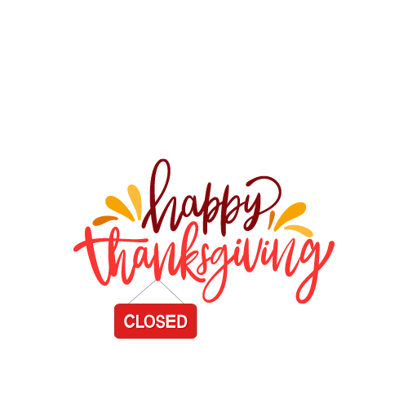 | 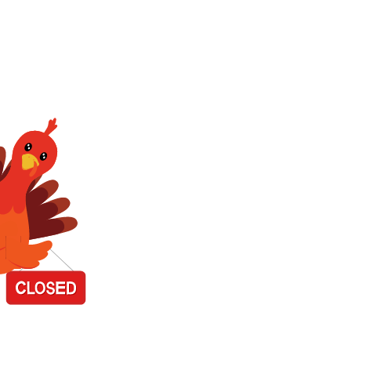 |  | 25  9:15a-5:30p Foot Clinic –Appt. Required  10a Silver Sneakers  Blood Drive 11:30a-3:30p  1-4p Chess Club  2-3p Diamond Art Club |  | 26  9a Zumba Gold  10a Zumba Gold  12:30p Euchre  12:30p Jeopardy | 27  10a Silver Sneakers  12:30p Mahjong  2p-4:30p Commodities
Light Bites  Southwest Side Salad, Chicken Tortilla Soup, Kiwi | Light Bites  Turkey Sub, Minestrone Soup, Grapes | Light Bites  Side Chef Salad, Cheesy Potato Soup, Pear | Light Bites  Won Ton Soup, Mandarin Salad, Kiwi | Light Bites  Ham & Cheese Sub, Cabbage and White Bean Soup, Pineapple

